SAGE FRAIL BENEFICIARIES MAY NOT NEED TO COLLECT MONEY AT PAY POINTS
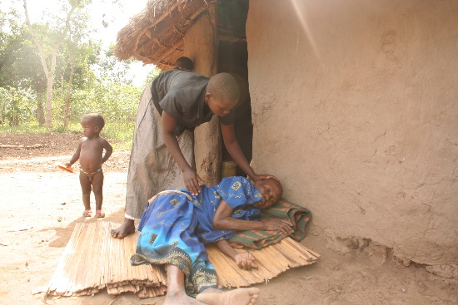
“In the event that a beneficiary is too weak or frail to collect his/her senior citizens grant (SCG) they have an opportunity to register a some-one else who they trust so that the chosen alternative can pick money on behalf of the beneficiary. This representative referred to as an alternative beneficiary must have a national ID and will be enrolled to the programme before they start picking money” This was the headline message by the LC 5 chairperson Bugiri, Marijani Azalwa, as he addressed beneficiaries from Kapyang Sub-county.
A frail beneficiary Manjeri Taaka of Naluwerere , Bugiri after receiving money from her daughter the alternative recipient
Some beneficiaries have been apprehensive about alternative beneficiary service citing lack of trust but the programme is to come up with an impromptu routine check where officers can check on the beneficiary to see if they receive their money from alternatives. This check in intended to take place every after four payment cycles.
Officers at the SAGE office say, this new mobilisation drive to register alternatives comes after increasing reports of beneficiaries dying either on the way or at the pay point.
Head PMU Stephen Kasaija said that “the programme has always provided an opportunity for frail beneficiaries to register alternatives but this is an option that cannot be forced on them” He said some of the beneficiaries usually develop complications while moving on Boda Boda motorcycles due to age and other ailments. This needs to be addressed because we need them to live longer to continue benefiting.
This initiative is also aimed at preparing beneficiaries for the 80+ National Roll out. Parliament in September last year, recommended that government prepares to roll out the SAGE programme to the whole country come July, 2019. The National Rollout will target all older persons who are 80 years and above. The recommendation also calls on government to present work out a mechanism and present a plan where the beneficiary targeting age with be reduced to 65 in the next 3 years.

